# **CS370: Assignment 3 - Documentation**

**Family Name:** Goh

**First Name :** Wei Zhe

**Email id : weizhe.goh@digipen.edu**

_________________________________________________________________________

Declaration:

I hereby declare that I adhere to the Academic Integrity Policy stated in the syllabus document. In addition, I also declare that the output images shown in this document are solely taken from the project that I have implemented for this assignment and the same output image will be generated when run in any Digipen PCs using the submitted project.



_________________________________________________________________________

**Part 1 - Direct Implementation (Brute Force Method)**

Fourier Transform

->

Inverse Fourier Transform

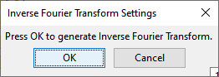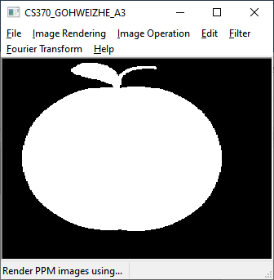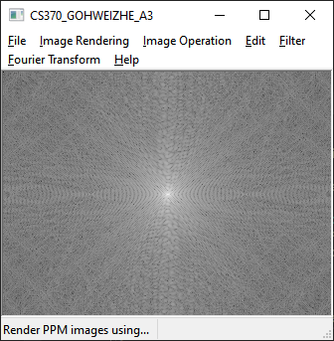

File -> Open -> Load Apple.ppm Image -> Fourier Transform -> DFT – Brute Force Method (10mins) -> Click OK -> Generate Inverse Fourier Transform (15mins)

**Part 1 - Direct Implementation (Separable Method)**

Fourier Transform

->

Inverse Fourier Transform





File -> Open -> Load Apple.ppm Image -> Fourier Transform -> DFT – Separable Method -> Click OK -> Generate Inverse Fourier Transform

**Part 2 – Fast Fourier Transform (Butterfly Method)**

Fourier Transform

->

Inverse Fourier Transform



File -> Open -> Load Apple.ppm Image -> Fourier Transform -> FFT – Butterfly Method -> Click OK -> Generate Inverse Fourier Transform